# Introduction

We are a seed stage startup providing a technology platform that enables emerging market collection authorities to efficiently collect, direct and understand recyclables. Our platform uses an incentivizing recycling model to gather and understand individual user’s disposal related data, which we will use to educate the said users to reduce, reuse and recycle. We plan to also leverage the insight provided by these data presented via a dashboard to help collectors optimize sorting costs, routes, and drive awareness campaigns.

**Figure 1: Our position in the value chain**

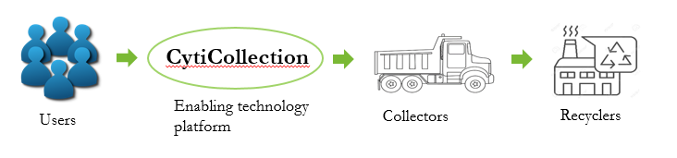

Our platform aims to solve the crisis by using an incentivizing and gamifying process to get individuals to throw, segregate, and understand the ‘critical’ recyclable garbage. The core of this is a mobile app that we will deploy so that existing disposal and collection infrastructure ecosystems can effectively collect the sorted garbage, and while doing so gather a wealth of data about the disposal patterns of users. Subsequently, our platform also doubles down to educate individuals of reducing, recusing, and recycling their waste. Thus it’s a positive feedback loop; better education leads to better sorting, which leads to more effective usage of the app, which will thus gather and learn further disposal trends. As such we believe this approach is highly scalable.

Once our app has a large enough user base, we will enter Phase II, where we will expand to deploy autonomous smartbins to critical areas (i.e. large crowd gathering areas near waterways) that will also integrate into the same redemption platform.

# Sri Lanka’s Pain Points

Sri Lanka is a prime example of disastrous waste management. The extremely inefficient waste disposal systems means that most waste, regardless of their nature, gets accumulated in landfills and dumps. The tragic incident in Meethotamulla in April 2017 where a garbage mound collapsed tragically killing 32 people is a grim reminder that our country desperately needs control of the situation. The Meethotamulla garbage mound was where Colombo’s garbage was being dumped with around 23 million tonnes of it piled on.

Moreover, according to the earthday.org, Sri Lanka is placed as the 5th largest plastic polluter in the world (among China, Indonesia, the Philippines, and Vietnam).

Realising the problem at hand however, progress is being made. There are several waste recycling facilities emerging, both private and public. A few examples of the local recyclers include:

* Viridis - plastics, including PET bottles
* Eco Spindles - PET bottles, HDPE bottles
* Piramal glass - glass manufacturer and recycler)
* E-waste collection - Cleantech
* Neptune Recyclers - paper & board

There are also many fragmented ‘Bothal/Pathara’ small shops that try and separate out reusable items (e.g. large metal objects, E-Waste, glass alcohol bottles, etc.). But the underlying problem still remains - hardly anyone is incentivised to recycle properly, and collections and integration of these systems remain inefficient.

# Existing solutions

There are a few existing local solutions to help cope with the various issues of recycling. A few respectable ones include Plasticcycle, which has placed specially designed bins to support responsible disposal of recyclable plastic. The initiative is supported by two corporate giants in Sri Lanka, Keells and Elephant House. However, smaller start-ups are also exploring the incentivizing model e.g. instant cash at ATM for bottles (like in Germany) and a similar model to ours, paying customers in mobile credits for recycling their waste.

# Business model

So why are we different? Because our entire focus is on building an ecosystem that leverages the power of data and education, scales rapidly, and is asset light (we don’t run our logistics and collection, we work with an established partner). Nothing with such a strong focus on data and building an integrated platform has been tried yet.

Our business, CityCollection, has its primary source of revenue as the recycler’s payment for recyclable items, which will be mainly used to 1. pay the collector the expenses of the logistics system and 2. user redemption.

### Collection Model

The business relies on incentivizing customers which will require being able to uniquely ID their waste contribution. We will be providing users with their own unique QR codes and IDs, which will pasted onto their garbage disposal bags (which will be returned on their next scheduling).

Once a pickup is scheduled, our platform will route a truck (given sufficient collection quantity along the path). Where it will deliver the content to the sorting arm of the recycler.

Here the sorters will use the Validation app (see section XXX) to manually verify if the number entered by the user is the correct amount of recyclables. Once data is mapped to the user, we will provide the redemption when the cash is received from the recycler. Validation by the collector can be done at the user’s premise (e.g. laptops) or on collector’s premise (e.g. lots of PET bottles), via the existing network of manual sorters. **The important point in our system is that no new infrastructure or redesign is necessary to any collector, just a few simple add-ons**

**Figure X: Our business model**

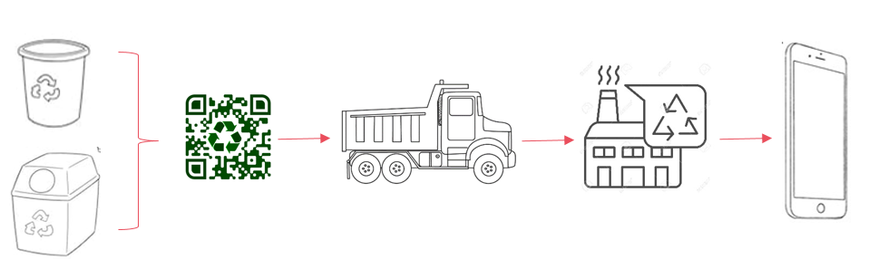

### Financial Model

Increased volume translates to better operating leverage. Our platform aims to build the scheduling service with route optimization (via Google maps) so that the maximum number of items can be collected per km travel. According to our research and discussions, a typical break even for a collector’s truck is ~$750 (based on 40km roundtrip in Colombo including collection labor; requires a minimum load of 500kg of plastics or ~25,000 PET bottles).

**Figure X: Financial model**

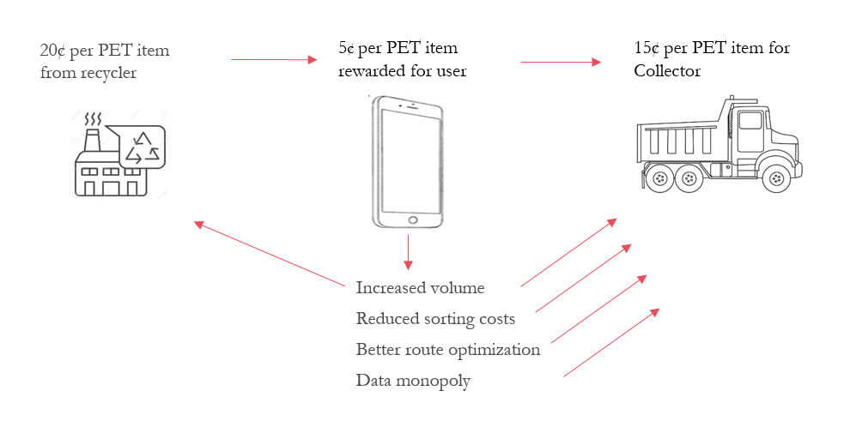

Carefully balancing supply/demand, volume growth, and operating costs is a precarious one. We are working with collectors to figure out what the most optimal redemption amount per user is so that we can drive sufficient growth and still cover logistics and add profit.

**Figure X: Effect of different user redemption rates on collector profits**

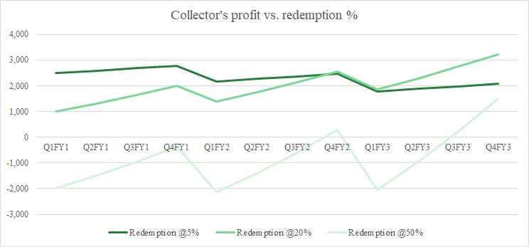

# The Platform

>> Describe aspirational final setup API...

**Figure X: Our platform**

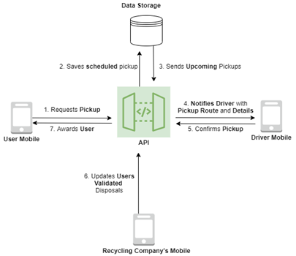

Currently, our working POC utilizes five main components, two of which are exclusive for CityCollection. Starting with the User Mobile, this is the actual user’s mobile device, they interface with the whole system using the CityApp. Then there's the API which is the core of the whole system, this API interfaces with all the other components, not to mention is responsible for running machine learning training jobs and pushing notifications. Then there is the Data Storage responsible for storing the user and system data. These three things are essential to each of our solutions CityCollection and CityBin, both are described below.

Specifically for CityCollection, there is the driver mobile application that receives notifications and route information for the driver to plan their garbage pickup routes. There is also the recycling company’s mobile app which allows them to validate garbage items picked up.

*The diagram above does not include an actor for the dashboard and for CityBins as those are still under development*

Our primary setup and stage one is called CityCollection, with stage two followed by CityBin both of which will eventually use our proprietary API.

1. Stage 1: CityCollection is the scalable solution designed to address household sorting and education
2. Stage 2: CityBin will address all disposal of garbage by including automated sorting bins

### Mobile App

Our mobile app is the core interface for the users and will have the following functionalities.

>> Booking for pickups

-See upcoming pickups/cancel upcoming pickups

-See nearby CityBins for disposal

-Prize redemption

-News/Advertising

Gamification is a popular method employed by fitness companies to get a user to sustainably support an activity, such as exercise. We are applying the same framework and designing a gamification systems that;

1. Leaderboard for area, with more prizes

2. Collection rewards and patterns

3. Community driven efforts

### Dashboard

Given the approach we are taking to solve the everlasting issue, which is the lack of guidance and education to the local communities on the importance of proper garbage disposal habits, it is vital for us to derive the data we will be collecting from the users in terms of disposal habits and and identifying areas in which methodical disposal is taking place in order to build the ecosystem we plan to achieve. To address this, we are building a Dashboard, through which we will be giving meaning to the data we collect by creating visual representations so that the collection authorities could monitor the progress we are making and execute operations in a concise manner and make informed decisions to further drive growth in terms of methodical disposals within communities, which will in turn result in the growth of recyclable waste collection.

One of the key components of the Dashboard will be a heat map, representing the active recyclers we will build through our ecosystem. Through this, recyclable waste collection authorities will be able to visually see where there is user growth and where waste disposal is taking place in a methodical manner. Given that information, in comparison, we can derive the locations in which waste disposal is not taking place methodically. With the help of this data gathered, we will be able to further grow our user base exponentially by providing targeted education with the use of news articles, blogs and videos in order to motivate the communities in these areas to get on board with the ecosystem we plan to build.

In addition, we will enhance the use of this Dashboard by displaying statistical information concerning the growth and progress we are making in terms of recyclable waste collection in order to further understand the patterns of disposals made in terms of types of recyclable waste thrown away, helping us understand the contribution made from each location(City), and the gap that we need to meet in terms of the waste that is not making it into the ecosystem and is held redundant on the streets.

These are the core responsibilities of the Dashboard as a component in our solution. It will act as the middleman in between us (the data we will be collecting from users) and the collection authorities, giving them meaningful information to make progress and reach a wider pool of communities on the journey ahead in terms of solving this crucial problem.

### 

### Crowdsourced Data

As an initial approach, we collected recyclable waste disposal data by providing people in our local community with an online form, in which they were required to fill a few fields related to the recyclable waste they were throwing away on a daily basis.

Below is a screenshot of the form that we asked people to fill before throwing away their waste.

The below set of screenshots (**Figure X to Figure X**) is an initiative taken to bring life to our POC during the inception of our solution. This is only an initial approach we took in order to gather as much data as possible to better understand how we would gather such related data with the help of our end to end platform.

**Figure X: Data Collection Form**

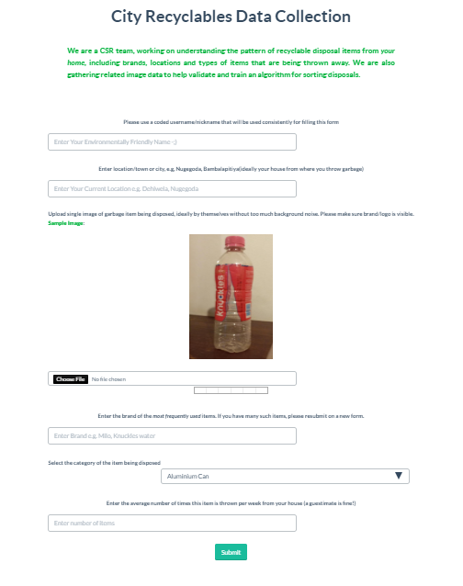

Using this approach we were able to collect data concerning the location in which people were disposing of waste, and the types are waste too. Below is some of the data we collected from people in several locations.

**Figure X: Data Collected from Users**

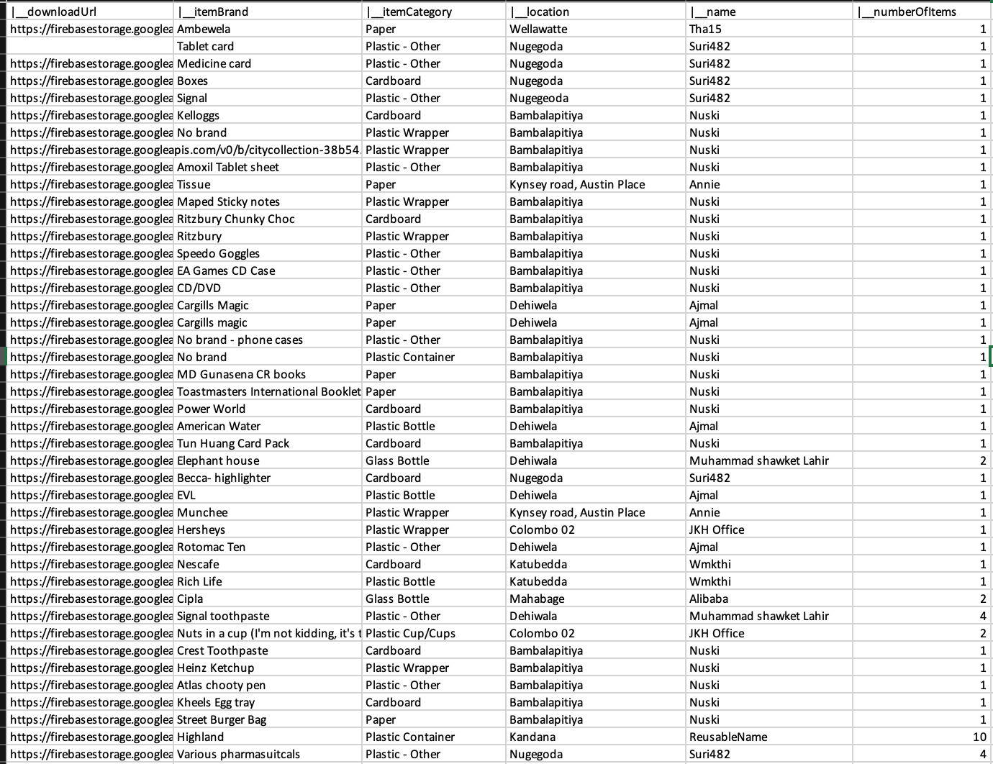

As shown in the screenshots above, this form is an initial idea on the type of data we will be collecting from the users on our platform. With the data we collect, we will be deriving meaningful information on the Dashboard to grow potential of achieving the vision of our ecosystem.

Below is an example of a heat map based on the data gathered with the help of this form.

**Figure X: Heap Map Representing the Users Actively Recycling in Specific Areas**

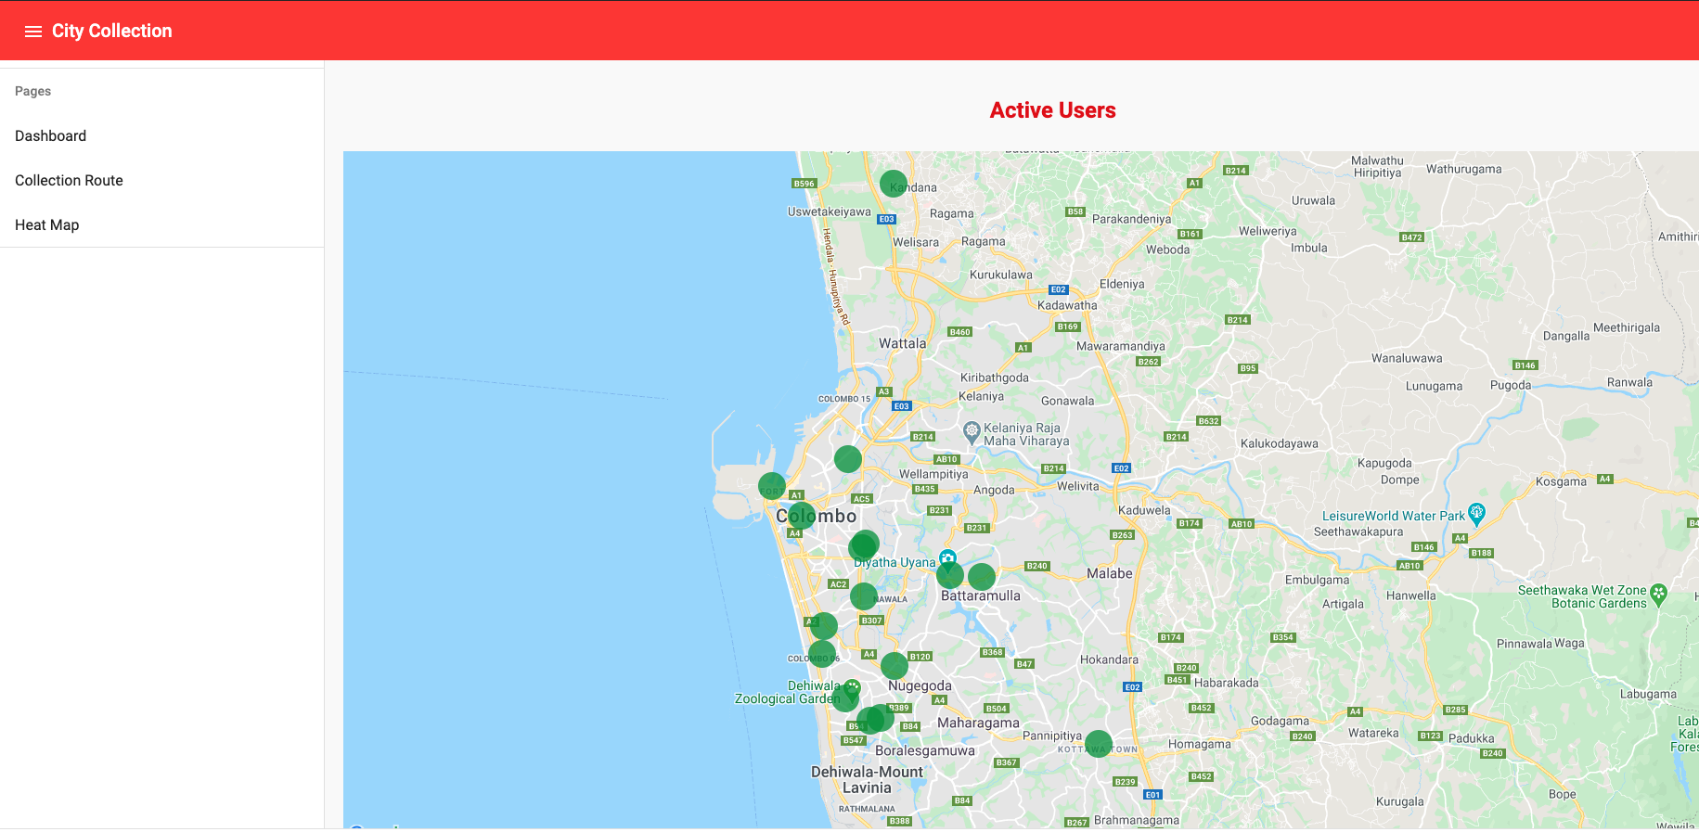

### CityBin

As mentioned CityBin is phase II where we leverage a sufficiently large user base (>10,000) to deploy smartbins to gather recyclable garbage and redeem points. The bins will be placed in areas where large crowds gather, especially near waterways (after analyzing data we gathered from community level user disposal trends)

>> image CityBin

**Figure X: SOLIDWORKS preliminary skeleton**

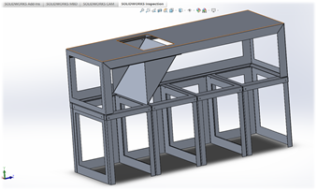

### Image recognition

We will be using image classification and object detection for CityCollection and CityBin respectively, but for different purposes.

**CityCollection - Object detection and classification:**

**For CityCollection, image recognition is not a core part of the business model.** However, it is an add-on method by which we incentivize users to take labelled pictures which forms a supervised dataset that can be used for future industrial sorting applications. It also forms the database required for Phase II, CityBin, which we will discuss later.

We are using the pre-trained YOLOv3 which we have trained on custom data that we have (crowdsourced data, described in section XXX). This model will be hosted in the cloud and identify specific brands. It is currently being trained to achieve high accuracy with high IOU

To gather sufficient data, we have to pay our customers (like Amazon’s mechanical turk) for labelling the dataset. We are currently building a system of redemption for the images through which we pay them a small fee for each labelled data. The income for this is expected to be launched through subscriptions by providing the crowdsourced data, or fully trained algorithm solution to industrial waste sorters and other interested disposal authorities. Naturally, we will not launch a payment until we have gathered evidence and struck a deal with said industrial data customers.

We are currently in the early stages of the training, yet we are seeing convincing performance in our model. Our latest custom YoloV3 is capable of identifying 4 brands (trained purely through the crowdsourced image data; to be extended to >500 brands as data comes in) to achieve mAP of 70% @IOU of 50%. Our aim is to train the model to be capable of high mAP’s at high IOUs, given the density of disposed items that may require detection at a sorting conveyor belt in a potential industrial use case.

We have used a variety of image augmentation tools, including changing hue, brightness, scaling, and background augmentation, to enable us to achieve this performance even with a small dataset. An example of the images are set below.

**Figure X: Detections of out-of-sample items**

#### 

Currently, the algorithm is very effective in identifying the item when its brand is clearly visible, however it becomes less confident (and thus doesn’t recognise) when the brand/logo is unclear, stretched, distorted, etc. We are currently in the process of experimenting with a variety of blurring and shearing augmentations to overcome this issue.

#### 

**CityCollection - Object detection and classification:**

Our other model is a mobile friendly device and works by classifying singular items at a time. It works by identifying the broad categories of objects in an enclosed trap (i.e. CItyBins disposal box). We have used the Mobilenet model and trained the last 3 layers of the model to our dataset. The challenges are much more muted with the model given that we are operating in a predefined environment. Albeit the training data are also required to be in this environment, thus we are using a variety of background augmentation tools to build a suitable dataset.

**Figure X: PET bottles in enclosure**

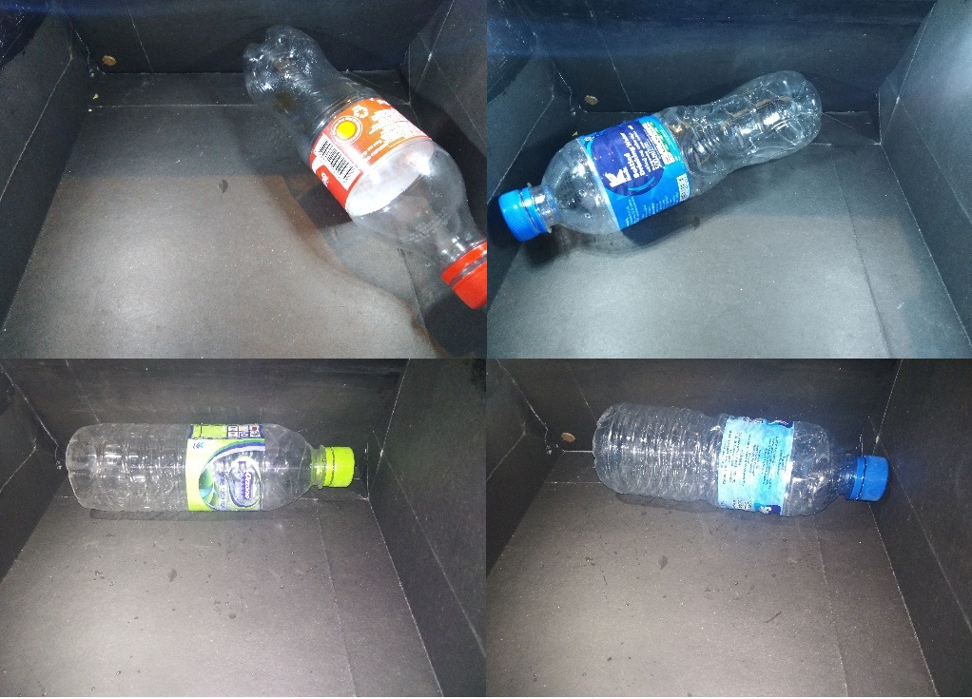

The model is capable of identifying PET bottles with >90% accuracy due to the constrained nature of the environment.

# How does it solve the problem?

To understand how our solution neatly addresses every problem in the challenge, either directly or indirectly, we have organised a Q&A session below.

## **Challenge 1 -** Improved Visibility of Plastic Waste Generation and Material Flows

* Southeast Asia’s existing systems are complex, often fragmented, and heavily reliant on the informal economy.
* Lack of visibility and transparency on plastic waste generation patterns as well as plastic waste material flows

Questions & Answers

1. How to better track and understand where plastic waste comes from and where it goes?

* The CC mobile app gathers information as to the houses that produce recyclables/non-recyclables via our QR code identification
* The dashboard tracks location, frequency, type, and even brand data via the image recognition portion of the app. The data is used to identify individual, community wise user patterns and behaviors to better focus collection efforts

1. Better understand waste generation based on its quality (type, cleanliness, etc) and source (urban/rural, commercial/household, community-level/country-level, etc)?

* Image recognition to help identify the cleanliness and type of recyclability
* The app doubles down to track the brands that use plastics and other waste via the image recognition algorithm, which adds additional incentive rewards points (economics explained in the Our Platform section)
* Meanwhile, CB, our second iteration improves on the data collection procedure by going directly to the source of outdoor waste disposal (e.g. shopping malls, events) where CC influence is only indirect (home based solution that still incentivizes you to carry plastics home for recycling)

1. Predict the consumer attitudes and behaviors to identify potential channels of influence on plastics?

* As explained, the dashboard summarizes all of the relevant data to help identify individual and community wise user patterns. The app also has an ‘Awareness!’ section which displays weekly updates about plastic and waste related issues as heads up (not in a bothersome way!) This initiates public education of the responsible disposal of garbage

## **Challenge 2** - Optimization of Circular Supply Chains for Plastics

* Collected-for-recycling rate of PET just ~26%, yet they import a large quantity
* Insufficient pricing of post-consumer materials/lack of visibility of post-consumer materials pricing for informal sector waste collection
* Lack of value creation mechanisms in the local supply chains
* Poor and short-term plastic waste collection efforts resulting in insufficient supply of quality, clean plastic feedstock
* Lack of new delivery models to eradicate usage of plastics

Questions & Answers

1. How might we incentivize responsible for plastic use and waste management?

* As mentioned, our CC system relies on two stage basis of incentification, 1. Recycler based incentives, 2. Image recognition drives marketing based incentives.
* Success rate of recycling is a direct function of the value of our incentive scheme. Our surveys across the regions of Colombo indicate that a range of LKR 150-400 per month is enough to get users to actively engage in collecting, and sorting their recyclable waste
* Subsequently, the payout from the recyclers requires and efficient operating base, one with already well established logistics infrastructure. We are currently exploring partnerships with a couple of private, waste collection entities regarding our solution to leverage their more efficient cost base and transfer maximum margin to users

1. How might we enhance the visibility, connectivity, and efficiency of informal sector waste collectors and aggregators?

* Answered above

1. How might we improve the visibility of pricing?

* Our platform shows the reward points for each type of item collected, helping users recognize the pricing of garbage. Furthermore, our system incentivizes the use of clean plastics, as the app penalizes unclean/incorrectly sorted waste.
* This method deeply embeds habitual recycling, which works even in places where there are no incentives

1. How might we better track and improve value generation across the supply chain?

* Image, location, time series disposal, brand, and type data is gathered to help the us/collector understand source, generation, and evaluate collection strategy and integrate fragmented value chain. Moeovevr, our state-of-the art image recognition and object detection algorithms will be trained on the wealth of image data to perform multilayered, segregation into increasingly more specific classes (e.g. reusable vs. reusable yoghourt cups packets). This enables more efficient industrial scale sorting reducing the requirement for manual labor (see object detection algorithm)

1. How might we best identify and improve awareness of existing gender and power dynamics across the value chain?

* No plans for this yet, but a requirement for gender at login will help us understand any dynamics here

## **Challenge 3** - Identification & Prevention of Plastic Waste Leakage

* 80% of ocean plastics come from land-based sources
* Assessment of contributions to ocean pollution from inland populations through riverine systems has been less frequent.
* Explore advanced data solutions to better map, monitor, understand, and forecast plastic leakage into the environment

Questions & Answers

1. How might we map and monitor plastic leakage entering waterways?

* This is an extension of the dashboard app in which we will layer the water bodies, including rivers and lakes nearest to the heat map for high activity locations.
* This allows for targeted collection and education in these critical zones.

1. How might we better understand and address how plastic leakage relates to external factors (landfill location, waste storage, socioeconomic factors, etc)?

* The sample user volume and location data is used to predict the fill rate of local landfills. It can even be used to predict collection capacities and requirements ahead of large beach events etc, and deploy resources effectively

# Our Team